Q1: Who is the senior most employee based on job title?

select*from spotify.employee

order by levels desc

limit 1

Q2: Top 10 countries have the most Invoices?

select billing_country as country,  
count(invoice_id) as invoice

from spotify.invoice

group by

billing_country

order by invoice desc

limit 10  
  
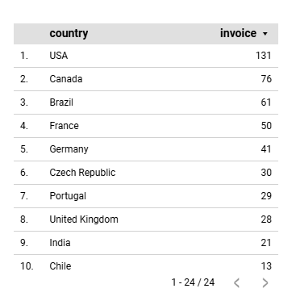

Q3: What are top 3 values of total invoice?

select total from spotify.invoice

order by total desc

limit 3  
  
  
Q4: Which cities has the best customers?

We would like to throw a promotional Music Festival in the

cities we made the most money. Write a query that returns top 10 cities

hat has the highest sum of invoice totals. Return both the city name &

sum of all invoice totals

select billing_city as City,

round(sum(total)) as invoice_total

from spotify.invoice

group byCity

order by invoice_total desc  
limit 10  
  
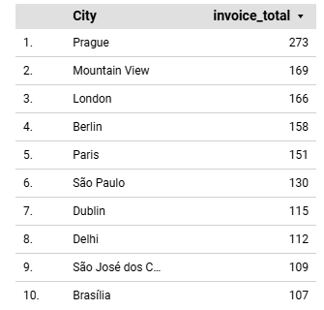

Q 5: Who is the best customer? The customer who has spent the most money will be declared the best customer. Write a query that returns the person who has spent the most money.  
  
select concat(customer.first_name,' ', customer.last_name)as fullname,

round(sum(invoice.total)) as total

from

spotify.customer

join

spotify.invoice

on

customer.customer_id = invoice.customer_id

group byconcat(customer.first_name,' ', customer.last_name)

order by total desc

limit 5

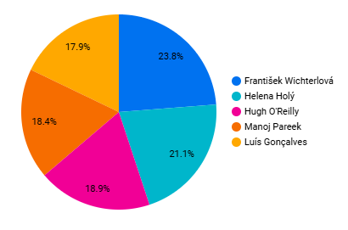

Q6:Write query to return the email, first name, last name, & Genre of all Rock Music listeners. Return your list ordered alphabetically by email starting with A  
  
  
  
select distinct email,first_name,last_name,genre.name as band_type

from

spotify.customer

join

spotify.invoice

on customer.customer_id = invoice.customer_id

join

spotify.invoice_line

on invoice_line.invoice_id = invoice.invoice_id

join

spotify.track

on track.track_id = invoice_line.track_id

join

spotify.genre

on genre.genre_id = track.genre_id

where genre.name ='Rock'

order by  email

Q7. Let's invite the artists who have written the most rock music in our dataset. Write a query that returns the Artist name and total track count of the top 10 rock bands

select artist.name as artist_name,count(track_id) as total_track,genre.name,

from spotify.track

join

spotify.genre

on track.genre_id = genre.genre_id

join

spotify.album

on album.album_id = track.album_id

join

spotify.artist

on artist.artist_id = album.artist_id

where genre.name ='Rock'

group by

genre.name,artist_name

order by total_track desc

limit 10

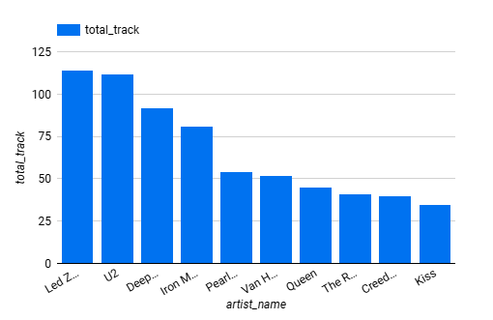

Q8.Return all the track names that have a song length longer than the average song length. Return the Name and Milliseconds for each track. Order by the song length with the longest songs listed first.

select name , milliseconds

from spotify.track

where milliseconds>

(select avg(milliseconds) as avg

from spotify.track)

order by milliseconds desc

Q9. Find how much amount spent by each customer on artists? Write a query to return customer name, artist name and total spent

with best_selling_artist as

(select artist.artist_id,artist.name as artist_name,

sum(invoice_line.unit_price*invoice_line.quantity) as total_spend

from

spotify.invoice_line

join

spotify.track

 ON track.track_id = invoice_line.track_id

 join

 spotify.album

 on album.album_id = track.album_id

join

spotify.artist

on artist.artist_id = album.artist_id

group by artist.artist_id, artist_name

order by total_spend  DESC

limit 1)

select

    customer.customer_id,

    concat(first_name,' ',last_name) as full_name,

    artist_name,

round(SUM(invoice_line.unit_price *invoice_line. quantity)) AS total_spent

from spotify.invoice

join

spotify.customer

ON customer.customer_id = invoice.customer_id

join spotify.invoice_line

ON invoice_line.invoice_id = invoice.invoice_id

join

spotify.track ON track.track_id = invoice_line.track_id

join

 spotify.album

  ON album.album_id = track.album_id

join best_selling_artist ON best_selling_artist.artist_id = album.artist_id

group by customer_id, first_name, last_name,artist_name

order by total_spent DESC;

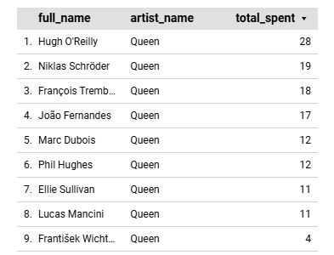

Q10. : We want to find out the most popular music Genre for each country. We determine the most popular genre as the genre with the highest amount of purchases. Write a query that returns each country along with the top Genre. For countries where the maximum number of purchases is shared return all Genres.

with top_genre as(

select count(invoice_line.quantity) as purchase,

customer.country,genre.name,genre.genre_id,

row_number() over(partition by customer.country order by count(invoice_line.quantity) desc ) as row_no

from

spotify.invoice_line

join

spotify.invoice

on invoice.invoice_id = invoice_line.invoice_id

join

spotify.customer

on customer.customer_id = invoice.customer_id

join

spotify.track

on track.track_id = invoice_line.track_id

join

spotify.genre

on genre.genre_id = track.genre_id

group by 2,3,4

order by 2 asc ,1 desc)

select*from top_genre where row_no=1

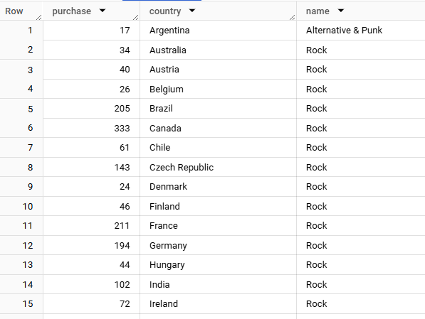

Q11: Write a query that determines the customer that has spent the most on music for each country. Write a query that returns the country along with the top customer and how much they spent. For countries where the top amount spent is shared, provide all customers who spent this amount  
  
  
with Customter_with_country AS (

    select customer.customer_id,concat(first_name,' ',last_name) as full_name,billing_country,

    round(SUM(total)) AS total_spending,

      row_number() OVER(PARTITION BY billing_country order by SUM(total) DESC) as RowNo

    from spotify.invoice

    join spotify.customer

     ON customer.customer_id = invoice.customer_id

    group by 1,2,3

    order by 3 asc,4 desc)

select * from Customter_with_country WHERE RowNo = 1

